Chapter 7, Solution 58.

For t < 0, 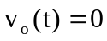
For t > 0,  